# TC_01_Countries_All

GET <https://dojobox-bootcamp.hasura.app/api/rest/country>

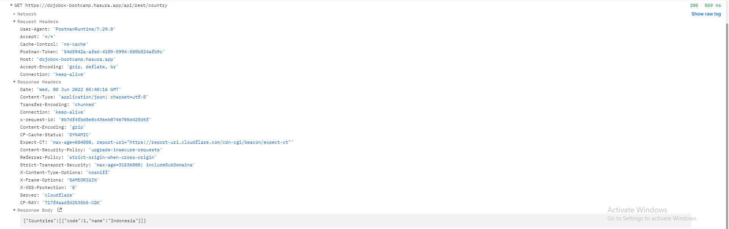

# TC_02_Countries_Single

GET <https://dojobox-bootcamp.hasura.app/api/rest/country/:countryId>

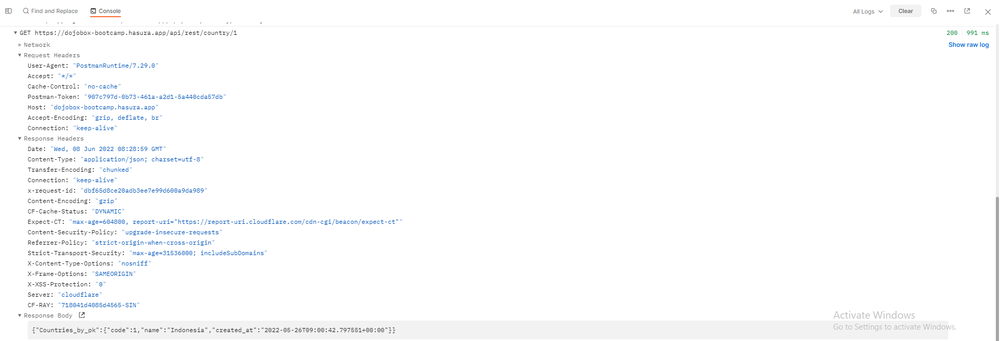

# TC_03_Users_All

GET <https://dojobox-bootcamp.hasura.app/api/rest/user>

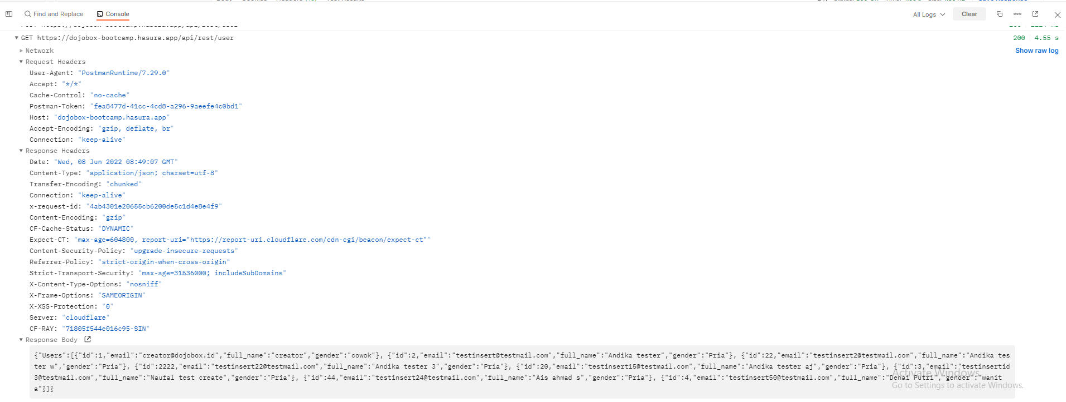

# TC_04_Users_Single

GET <https://dojobox-bootcamp.hasura.app/api/rest/user/:userId>

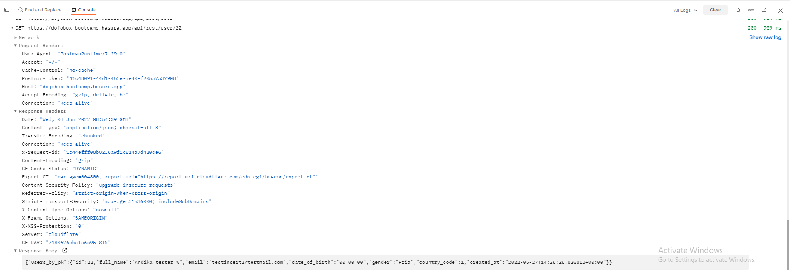

# TC_05_Users_Add

POST <https://dojobox-bootcamp.hasura.app/api/rest/user>

|  |
| --- |
| {  "id": 1111,  "email": "cicah@testmail.com",  "full_name": "Acicah" ,  "gender": "Wanita",  "date_of_birth": "00 00 00",  "country_code": 1  } |

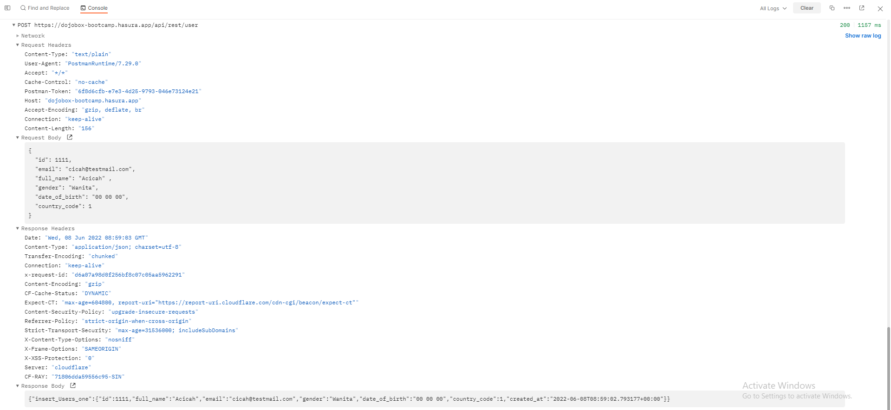

# TC_06_Merchant_List

GET <https://dojobox-bootcamp.hasura.app/api/rest/merchant>

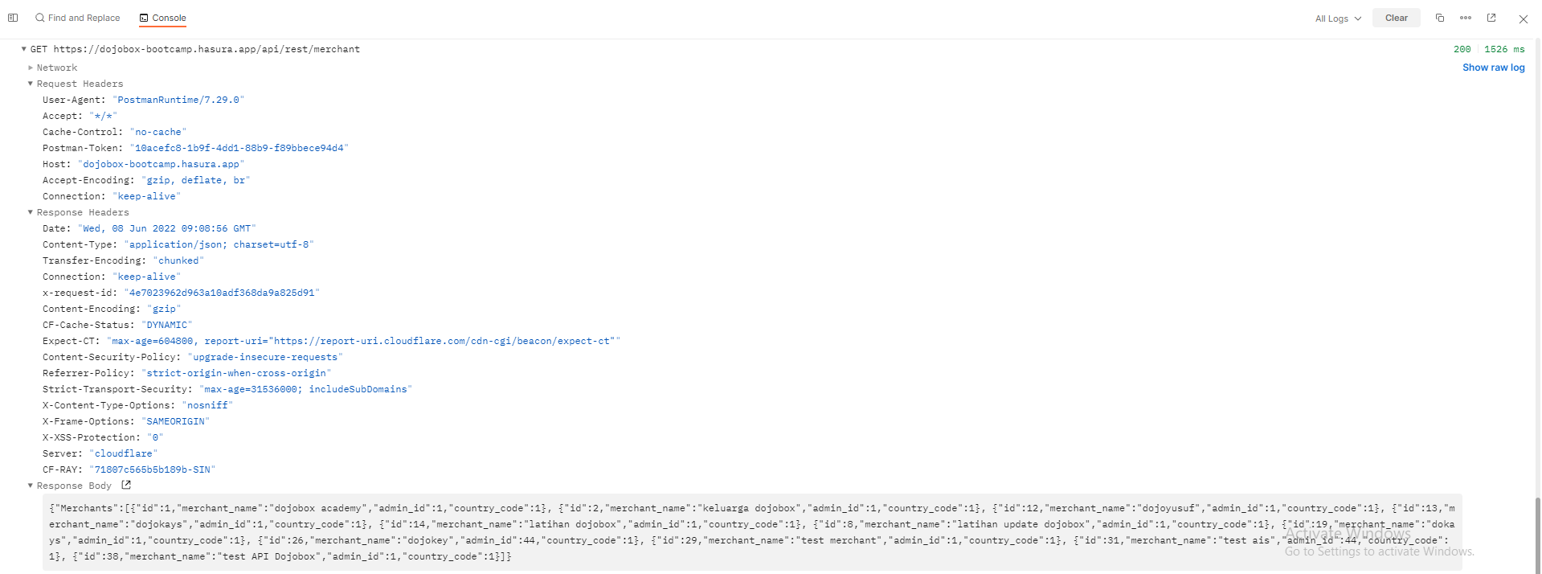

# TC_07_Merchant_Single

GET <https://dojobox-bootcamp.hasura.app/api/rest/merchant/:merchantId>

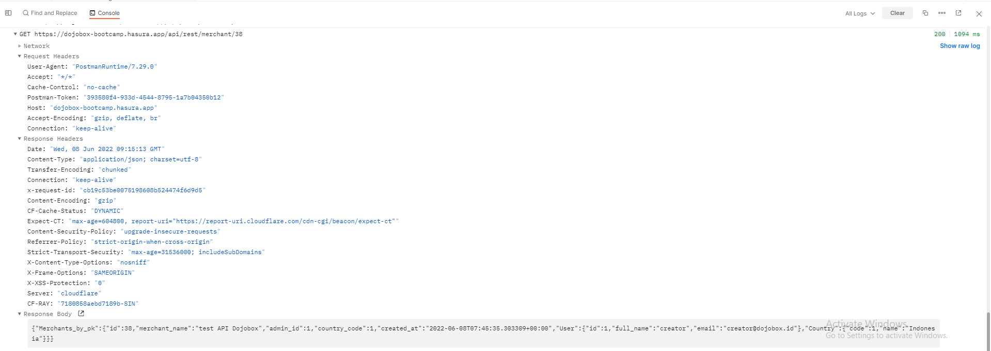

# TC_08_Merchant_Add

POST <https://dojobox-bootcamp.hasura.app/api/rest/merchant>

|  |
| --- |
| {  "admin_id": 1,  "country_code": 1,  "merchant_name": "cicahcorp"  } |

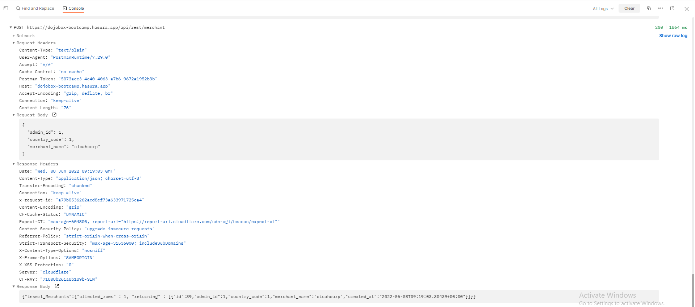

# TC_09_Merchant_Update

PUT <https://dojobox-bootcamp.hasura.app/api/rest/merchant/:merchantId>

|  |
| --- |
| {  "admin_id": 1,  "country_code": 1,  "merchant_name": "cicah.corp.update"  } |

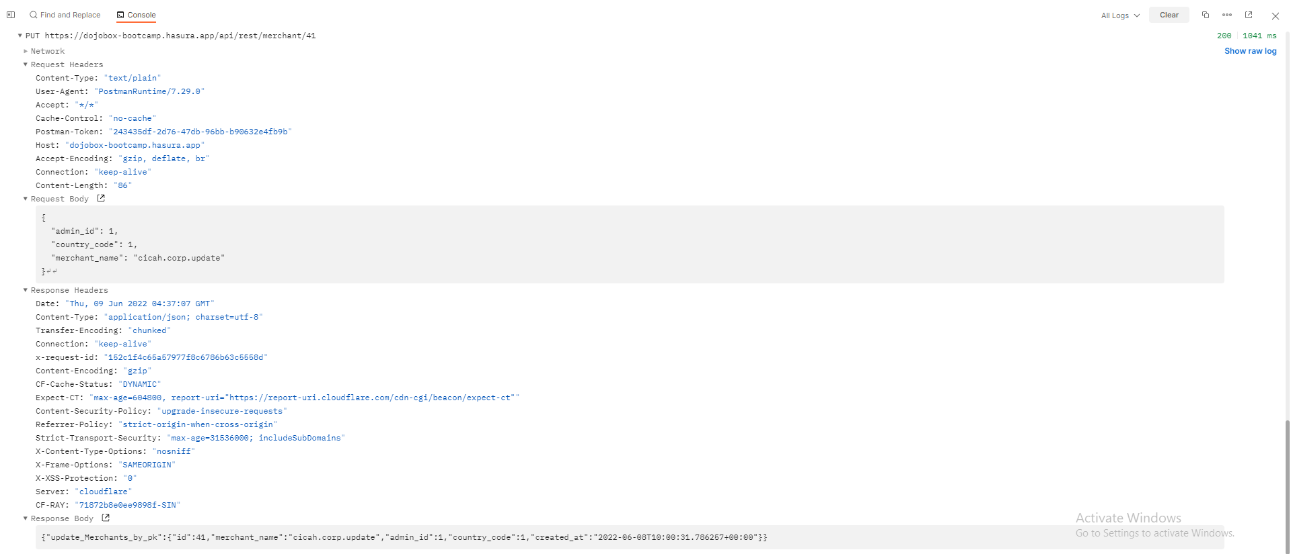

# TC_10_Merchant_Delete

DELETE <https://dojobox-bootcamp.hasura.app/api/rest/merchant>

|  |
| --- |
| {  "id" : 39  } |

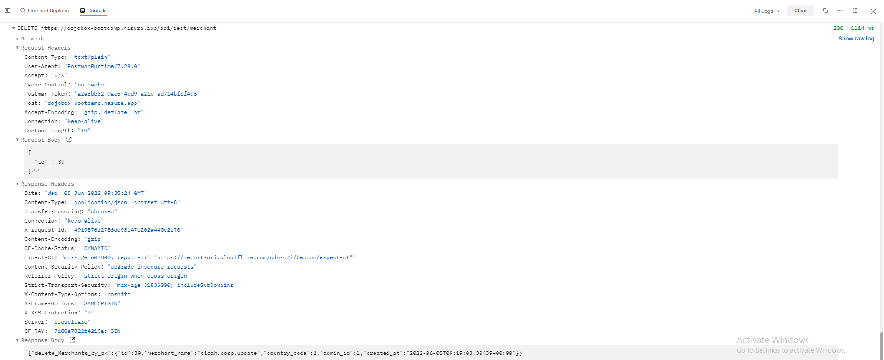

# TC_11_Product_All

GET <https://dojobox-bootcamp.hasura.app/api/rest/product>

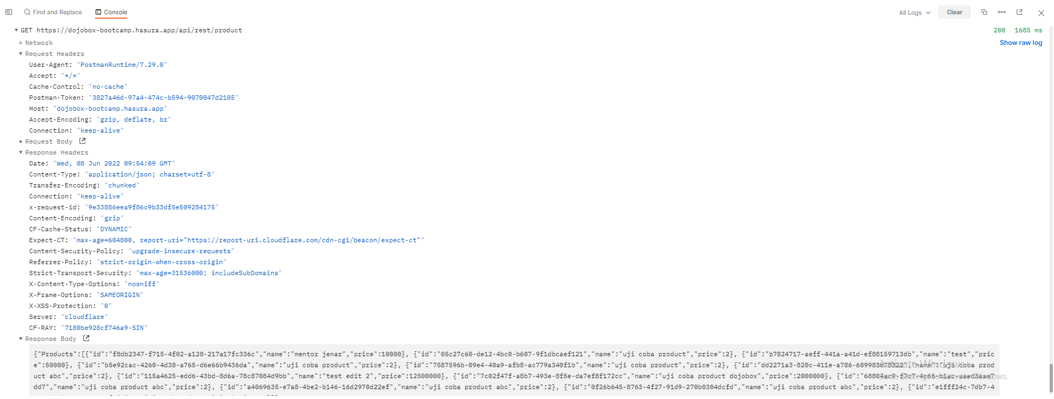

# TC_12_Product_Single_Merchant

GET <https://dojobox-bootcamp.hasura.app/api/rest/products/get-products-list-by-merchant-name/:merchant_name>

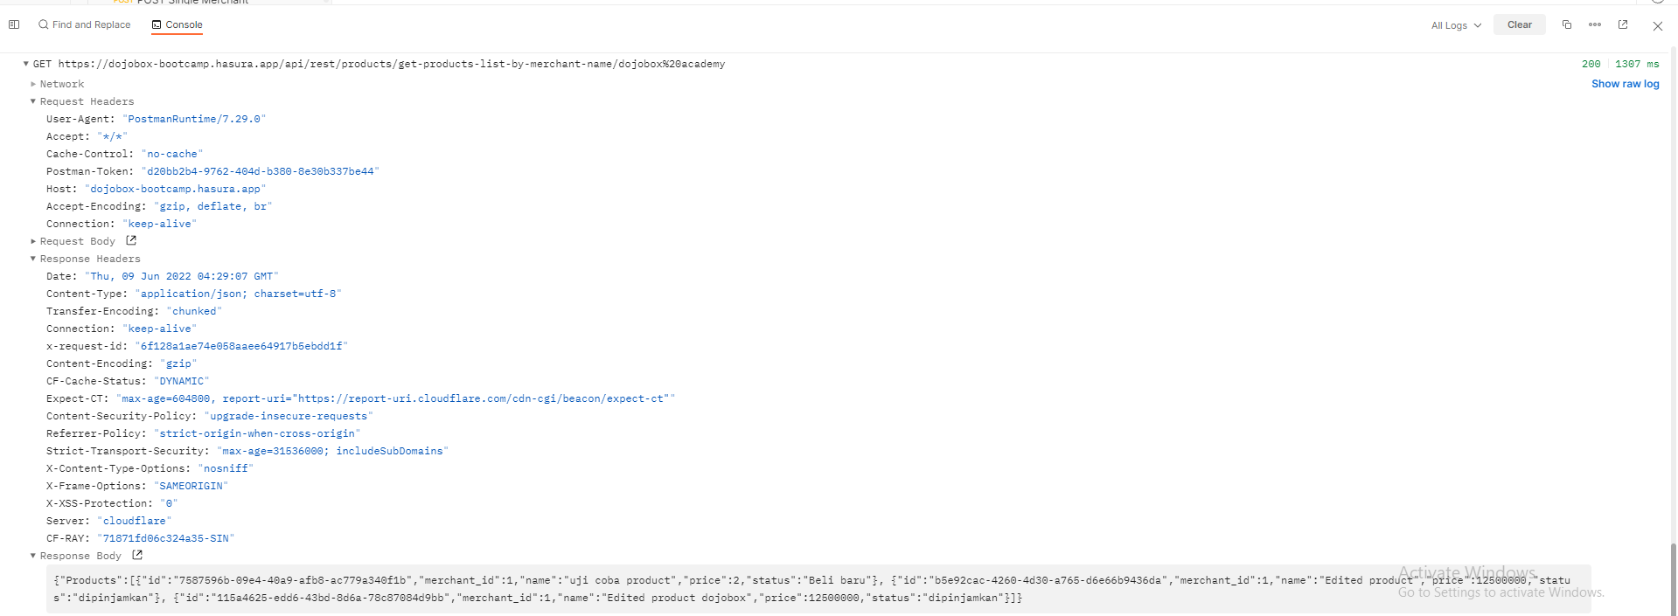

# TC_13_Product_Single

GET <https://dojobox-bootcamp.hasura.app/api/rest/product/:productId>

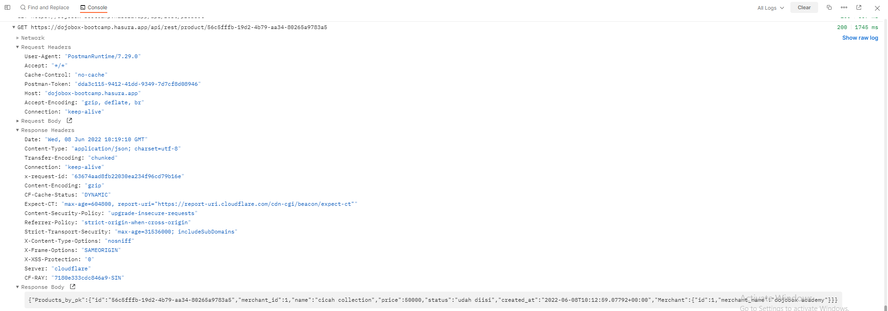

# TC_14_Product_Add

POST <https://dojobox-bootcamp.hasura.app/api/rest/product>

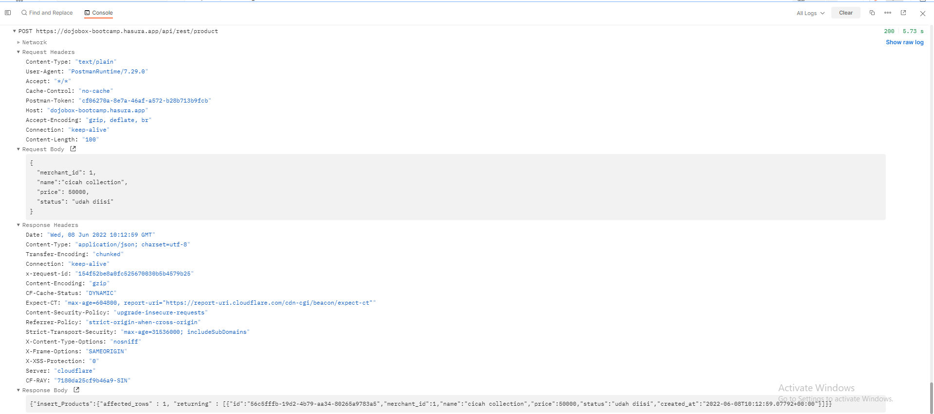

# TC_15_Product_Update

|  |
| --- |
| {  "name": "cicah collection update",  "price": 50000,  "status": "dipinjamkan"  } |

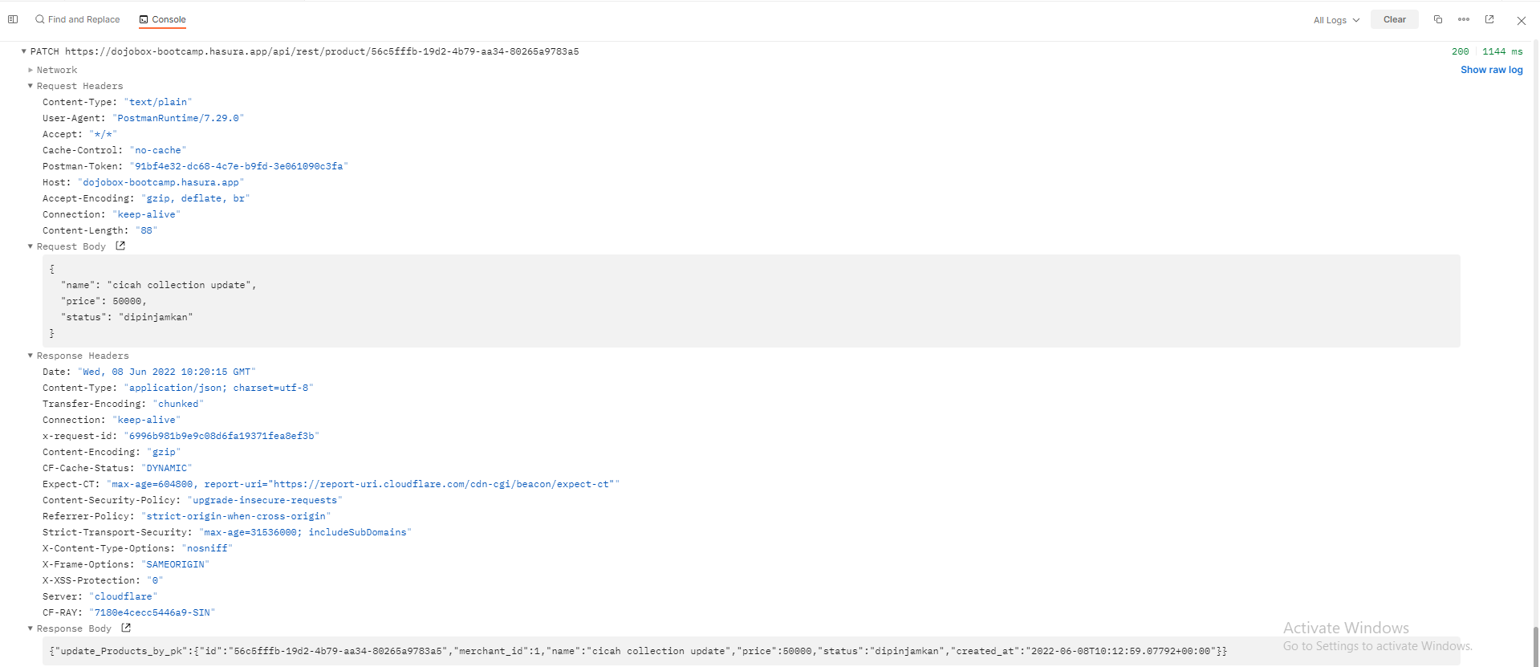

# TC_16_Product_Delete

DELETE <https://dojobox-bootcamp.hasura.app/api/rest/product>

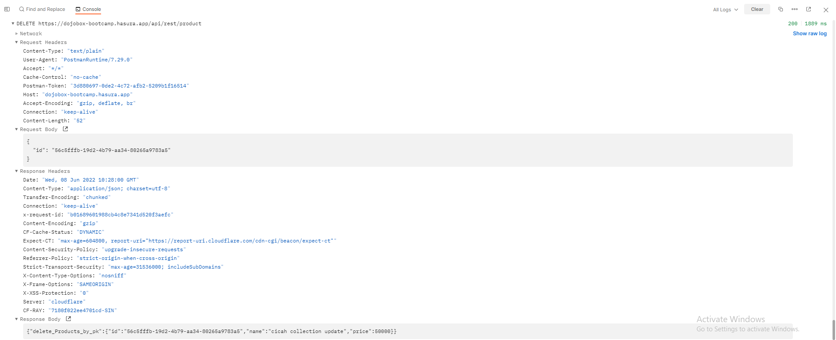

# TC_17_Order_All

GET <https://dojobox-bootcamp.hasura.app/api/rest/order>

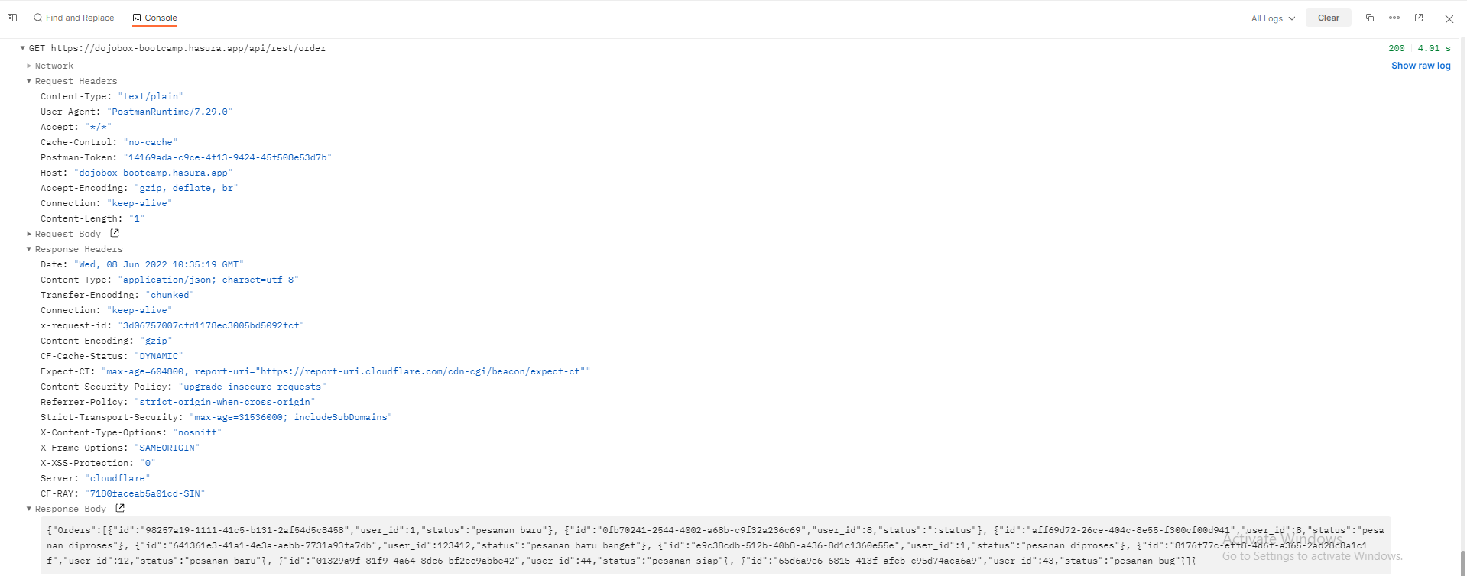

# TC_18_Order_Single

GET <https://dojobox-bootcamp.hasura.app/api/rest/order/:orderId>

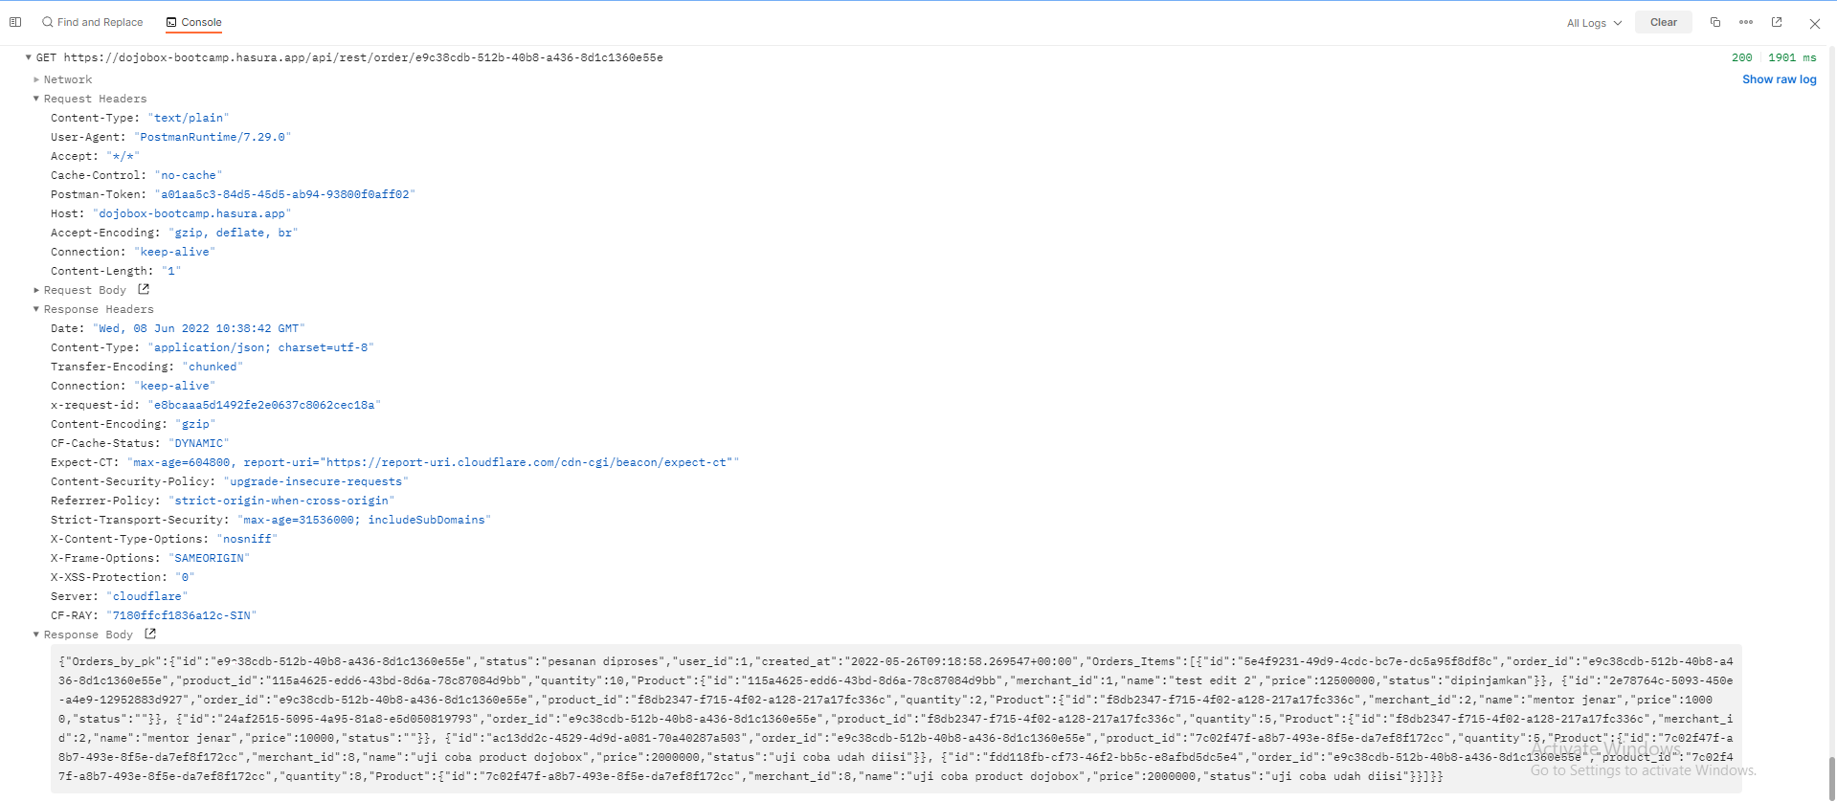

# TC_19_Order_Add

POST <https://dojobox-bootcamp.hasura.app/api/rest/order/:userId/:status>

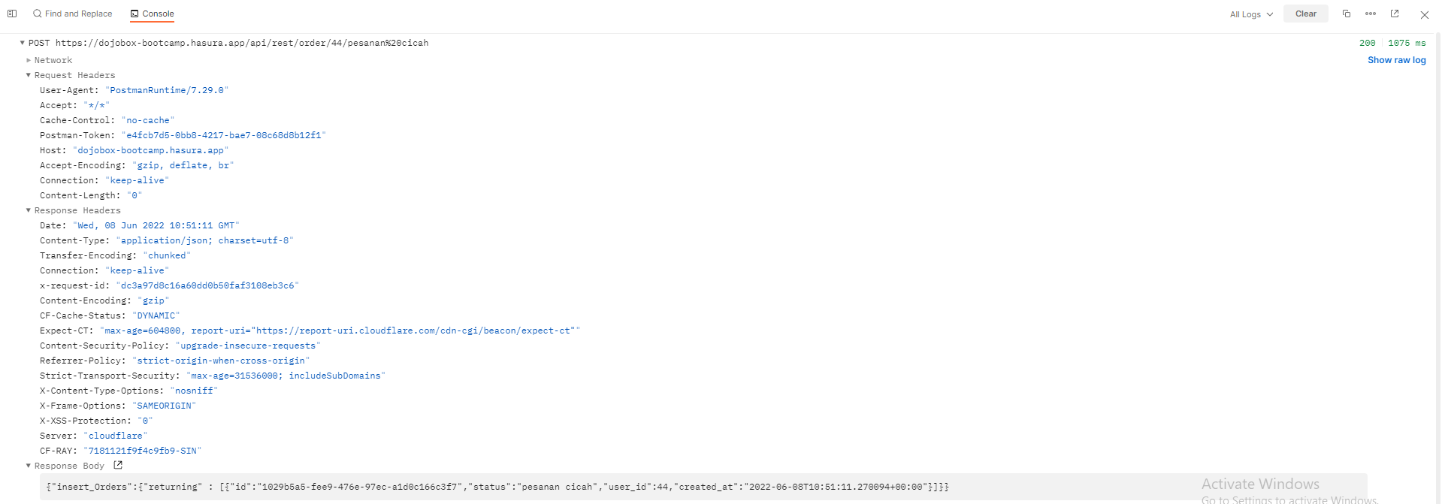

# TC_20_Order_Update

PATCH <https://dojobox-bootcamp.hasura.app/api/rest/order/:orderId>

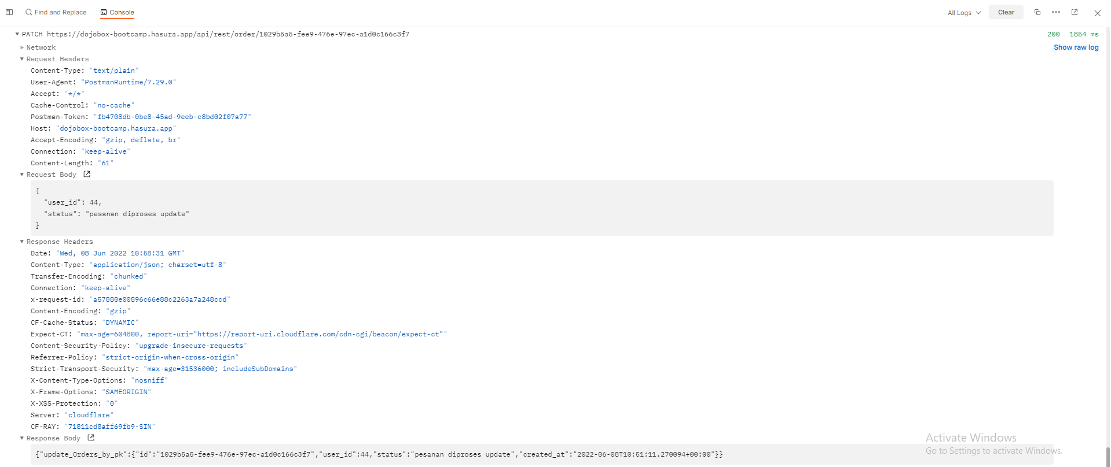

# TC_21_Order_Delete

DELETE <https://dojobox-bootcamp.hasura.app/api/rest/order/:orderId>

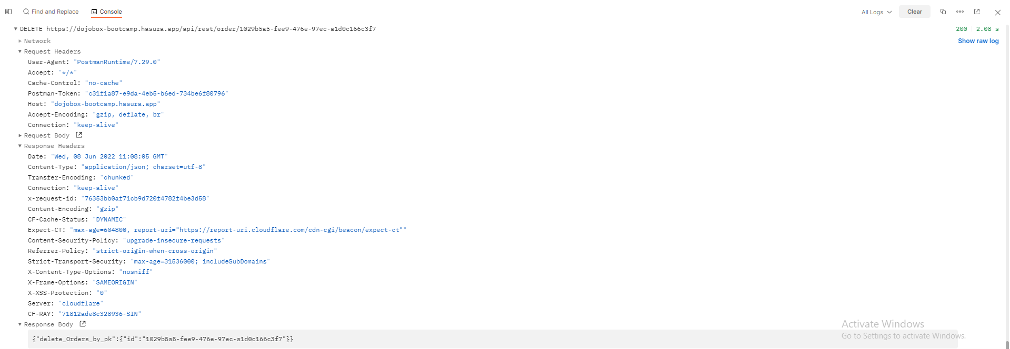

# TC_22_Order items_All

GET <https://dojobox-bootcamp.hasura.app/api/rest/order-item>

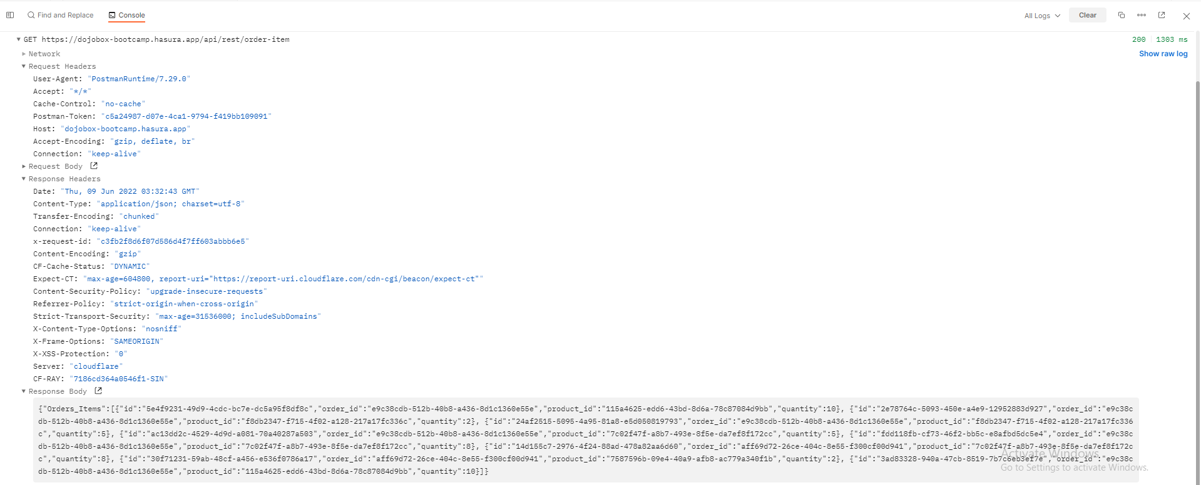

# TC_23_Order items_Single

GET <https://dojobox-bootcamp.hasura.app/api/rest/order-items/get-order-list-by-order-id>

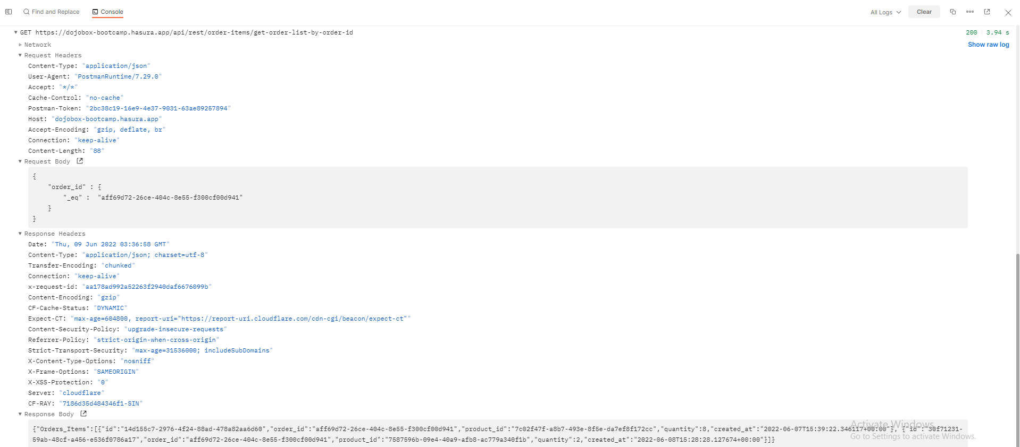

# TC_24_Order items_Add

POST <https://dojobox-bootcamp.hasura.app/api/rest/order-item/:order_id/:product_id/:quantity>

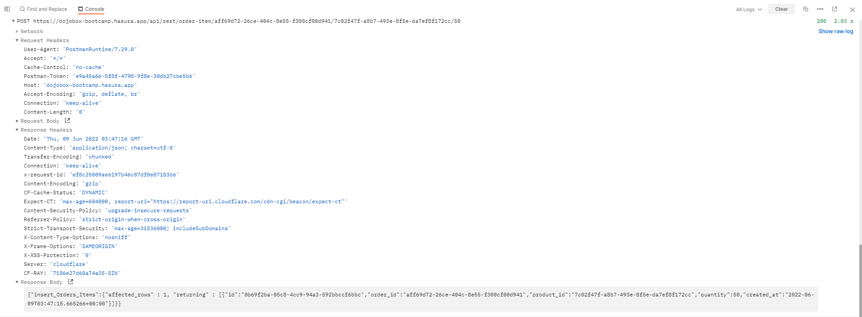

# TC_25_Order items_Update

PATCH <https://dojobox-bootcamp.hasura.app/api/rest/order/:orderItemId>

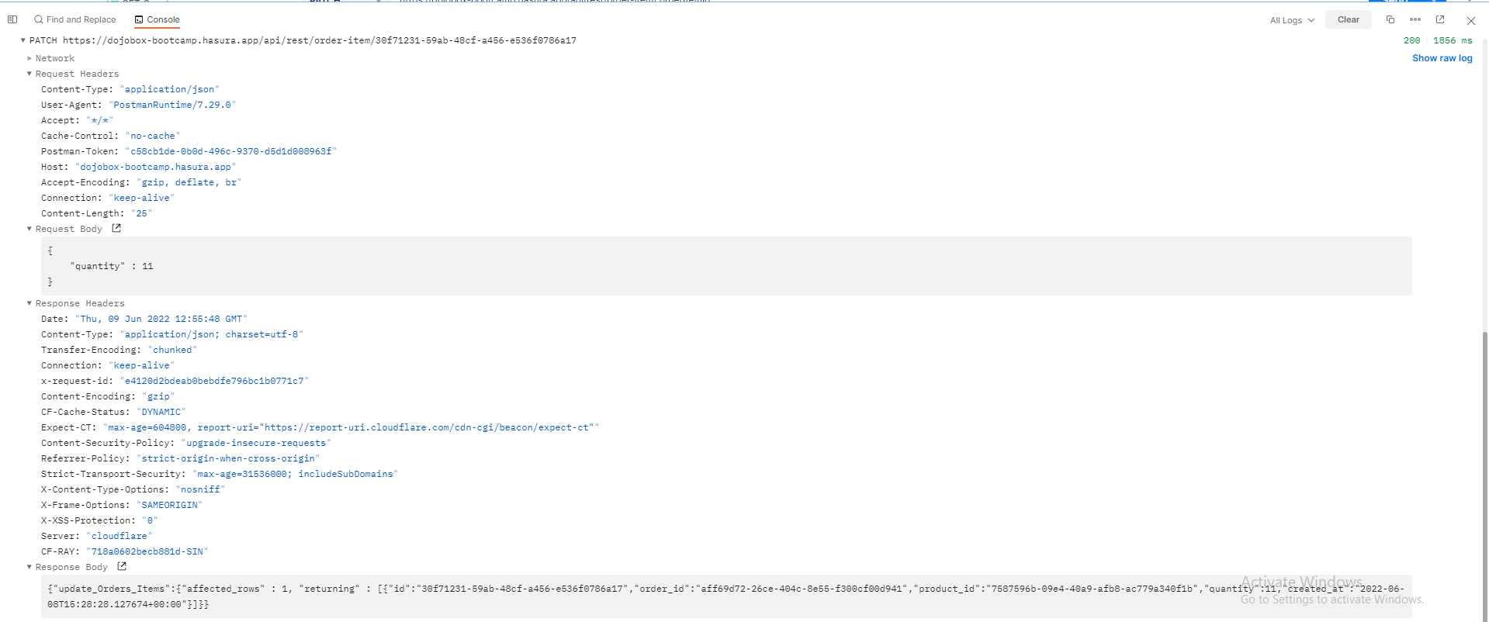

# TC_26_Order items_Delete

DELETE <https://dojobox-bootcamp.hasura.app/api/rest/order-item/:orderListId>

